People's Democratic Republic of Algeria
Ministry of Higher Educationand Scientific Research

MouloudMammeri University of Tizi-Ouzou
Tasdawit LmuludAt m£emmer



ⵝⴰⵙⴷⴰⵓⵉⵝⵎⵓⵏⵓⴷⴰⵝⵎⴷⴰⵟⵙ
Faculty of Building Engineering

Organize the:

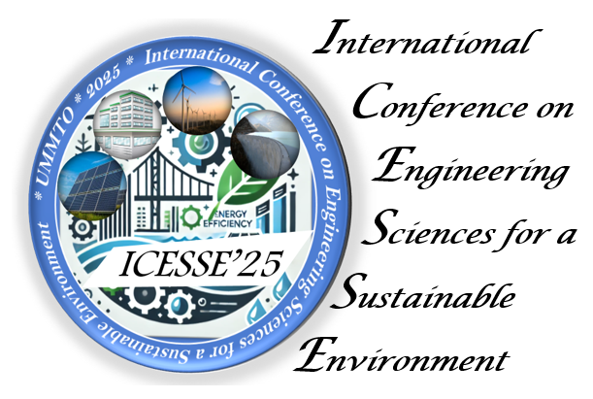

October 29-30, 2025
at MouloudMammeri University of
Tizi-Ouzou, Algeria

Honorary President
Prof. BOUDA Ahmed
Rector of MouloudMAMMERI University
Co-Honorary President
Prof. ZOUAOUI Salah
Dean of the Faculty of Construction Engineering
Conference Chair
Prof. TAOUCHE-KHELOUI Fatma
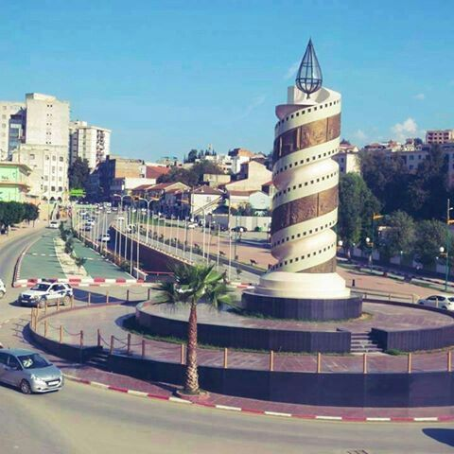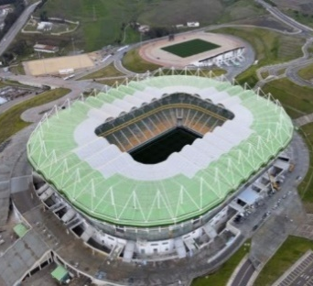

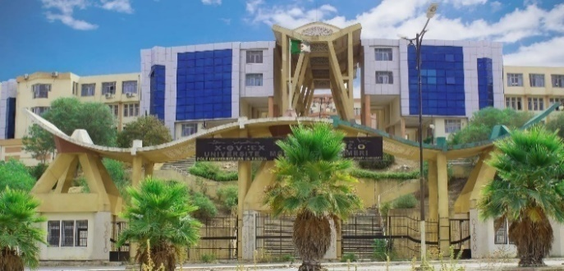
Preamble
The Building Engineering Faculty of the MouloudMAMMERI University of Tizi-Ouzou ishonored to host the "International Conference on Engineering Sciences for a Sustainable Environment – ICESSE’25", a significanteventbringingtogetherresearchers, students, andprofessionals in engineering and environmental sciences. Thisconferenceaims to explore scientific and technologicaladvancements in engineering and environmentalsustainability.
This editionfollows the seminarsheld in previousyears: CMMS08 and CMMS14. It seeks to expand itsscientificactivities by strengthening partnerships betweenacademic stakeholders and key players in the socio-economicsector.
The Faculty of Construction Engineering isproud to serve as a hub for interdisciplinaryideas and exchanges. This event aspires to reinforce international collaborations and promote innovative approaches to addressing global environmental challenges, offering a platform for reflection and discussion towardsustainable, environmentallyrespectfulldevelopment.
We invite you to activelycontribute to thisprestigiousevent to advanceresearch and innovation in service of the planet. Participants will have the opportunity to discusstechnologicaladvances and concreteprojectsaimed at improving the fields of Civil Engineering, Mechanical Engineering, Hydraulic Engineering, Energy Efficiency, and Environmental Engineering on local, national, and international scales.
Scientific Committee Chairs
Prof. BOUZELHA Karima
Prof. ALMANSBA Madjid
ScientificCommittee members
Pr. ABSI Rafik |  | Univ.Cergy-Pontoise, France
Dr. ADJRAD Rezki |  | Univ. Tizi-Ouzou, Algeria
Pr.AITAMAR Meziane Mohamed |  | Univ.Tiaret, Algeria.
Pr. AIT ATMANE Hassen |  | Univ.Chlef, Algeria.
Pr.AIT TAHAR Kamal |  | Univ.Bouira, Algeria.
Dr. AIT TALEB Souad |  | Univ. Tizi-Ouzou, Algeria
Dr.AKMOUSSI-FEDAOUIOurdia |  | Univ. Tizi-Ouzou, Algeria.
Pr. ALLAOUI Samir |  | Univ. Reims, France
Dr. ALI AHMED Chafika |  | Univ. Tizi-Ouzou, Algeria.
Dr. ALICHE Amar |  | Univ. Tizi-Ouzou, Algeria.
Pr. AMAOUZ Nouara |  | Univ. Tizi-Ouzou, Algeria.
Dr. AMOKRANE Mounir |  | Univ. Tizi-Ouzou, Algeria.
Pr. ASMA Farid |  | Univ. Tizi-Ouzou, Algeria.
Pr. ASSIH Jules |  | IUT Reims France
Dr. ATLAOUI Djamal |  | Univ. Tizi-Ouzou, Algeria.
Pr. AVCAR Mehemet |  | Univ. Isparta, Turkye
Pr. BAHAR Ramdane |  | Univ.USTHB, Algeria
Dr. BEHTANI Amar |  | Univ. Tizi-Ouzou, Algeria.
Pr. BENABOU Lahouari |  | Univ. Paris-Saclay, France
Pr. BENMAMAR Saida |  | ENP d’Alger, Algeria.
Dr. BENYAHI Karim |  | Univ. Tizi-Ouzou, Algeria.
Pr. BERREKSI Ali |  | Univ. Béjaia, Algeria
Pr. BOUAFIA Ali |  | Univ.Blida, Algeria
Pr. BOUAFIA Youcef |  | Univ. Tizi-Ouzou, Algeria.
Dr. BOUAMRA Youcef |  | Univ.Bouira, Algeria.
Dr. BOUDLAL Omar |  | Univ. Tizi-Ouzou, Algeria.
Dr. BOUMRAR Idir |  | Univ. Tizi-Ouzou, Algeria
Pr. BOURAS Rachid |  | Univ. Tizi-Ouzou, Algeria.
Pr. BOUSSAD Abbes |  | IUT Reims France.
Dr. BOUSSAFEUR Kaci |  | Univ. Tizi-Ouzou, Algeria.
Dr. BOUZEBOUDJA Fatma |  | Univ. Tizi-Ouzou, Algeria.
Dr. BOUZEBOUDJA Aldjia |  | Univ. Tizi-Ouzou, Algeria
Pr. CASCARDI Alessio |  | Univ, Calabria, Italy
Pr. CHELOUAH Nasser |  | Univ. Béjaia, Algeria
Dr. CHIBANE Hichame |  | Insastrasbourg, France.
Pr. DAHMANI Lahlou |  | Univ. Tizi-Ouzou, Algeria.
Pr. DAOUI Abdelhakim |  | Univ.Boumerdes, Algeria.
Dr. DEHMOUS Hocine |  | Univ. Tizi-Ouzou, Algeria
Pr. DELAUNOIS Fabienne |  | Univ, Mons, Belgium.
Pr. DJERBAL Lynda |  | Univ.USTHB, Algeria
Pr.FELLOUAHHachimi |  | Univ.Sherbrooke ; Canada
Pr.FERHOUM Rabah |  | Univ. Tizi-Ouzou, Algeria.
Dr. FERROUK Mohamed |  | Univ. Tizi-Ouzou, Algeria.
Pr. GHERNAOUT Redhouane | Univ. Bouira, Algeria.
Pr. GHERNOUTI Youcef | Univ.Boumerdes, Algeria.
Dr. GHOUILEM Kamel | Univ. Tizi-Ouzou, Algeria.
Pr. GUENFOUD Mohamed | Univ. Guelma, Algeria.
Pr. GRINE Ali | Univ.Boumerdes, Algeria.
Dr. HABAK Malek | Univ. Picardie, France
Dr. HACHOUR Kamel | Univ. Tizi-Ouzou, Algeria.
Dr. HADDAG Badis | Univ.Lorraine, France
Pr. HADJI Lazreg | Univ.Tiaret, Algeria.
Pr. HADJ MELIANI Mohammed | Univ.Chlef, Algeria
Pr. HAMIZI Mohand | Univ. Tizi-Ouzou, Algeria.
Pr. HAMMOUM Hocine | Univ. Tizi-Ouzou, Algeria.
Dr. HAMZAOUI Malek | Univ. Tizi-Ouzou, Algeria.
Pr. HEMMOUCHE Larbi | EMP, Algeria.
Dr. IDDIR Abdelkader | Univ. Tizi-Ouzou, Algeria.
Pr. KACHI Mohand said | Univ. Tizi-Ouzou, Algeria.
Pr. KAHIL Amar | Univ. Tizi-Ouzou, Algeria.
Dr. KENNOUCHE Salim | Univ.Bouira, Algeria.
Pr. KHATTAOUI Mohammed | Univ. Tizi-Ouzou, Algeria.
Dr. KHEFFACHE Toufik | Univ. Bejaia, Algeria.
Dr. KHELIL Nacim | Univ. Tizi-Ouzou, Algeria.
Pr. LE THANH Cuong | CEATS, Vietnam.
Pr. LEKLOU Nordine | IUT Nantes, France
Pr. LI Alex | IUT Reims France.
Dr. LOUADJ Samia | Univ. Tizi-Ouzou, Algeria.
Dr. LOUZAI Amar | Univ. Tizi-Ouzou, Algeria.
Dr. MAGAGNINI Erica | PolytechnicAncône, Italie.
Pr .MAKHLOUF Said | Univ. Tizi-Ouzou, Algeria.
Pr. MAY Abdelghani | EMP.BordjEl Bahri, Algeria.
Pr. MEDDI Mohamed, | ENSH of Blida, Algeria
Dr. MEDJNOUN Amal | Univ.USTHB, Algeria
Pr. MELBOUCI Bachir | Univ. Tizi-Ouzou, Algeria.
Dr. MEZIANI Faroudja | Univ. Tizi-Ouzou, Algeria.
Pr. MIHOUBI Mustapha kamel | ENSH of Blida, Algeria
Pr. MILANI Gabriele | Polytechnic, Italy
Pr. MILED Karim | UnivElmanar, Tunisia
Pr. MOHAMMEDI Kamal | Univ.Boumerdes, Algeria.
Dr. NEBBALI Arezki | Univ. Tizi-Ouzou, Algeria.
Dr. NECHICHE Mustapha | Univ. Tizi-Ouzou, Algeria.
Pr. NOORI Mohammad | CaliforniaPolytechnic, USA.
Pr. OULD OUALI Mohand | Univ. Tizi-Ouzou, Algeria.
Pr. REMINI Boualem | Univ.Blida, Algeria
Pr. RIAHI Mohamed Kamel | Univ, UAE
Dr. REZIG Amina | Univ. Bouira, Algeria.
Dr. SAHI Adel | Univ. Bejaia, Algeria.
Dr. SALEM Mehdi | Ecole des mines.Albi, France.
Pr. SEGHIR Abdelghani | Univ. Bejaia, Algeria.
Dr. SLIMANI Mohand | Univ. Tizi-Ouzou, Algeria.
Pr. SONEBI Mohammed | Univ. Belfast, UK
Pr. SOUAG Doudja | Univ. USTHB, Algeria
Pr. TAHAKOURT Abdelkader | Univ. Béjaia, Algeria.

Dr. TEBBICHE Hocine | Univ. Tizi-Ouzou, Algeria.
Pr. ZAZI Nacer | Univ. Tizi-Ouzou, Algeria
Dr. WELEMANE Helene | É.N.Ingénieurs, France
Pr. ZITOUNE Redouane | Univ.Toulouse, France
Pr. ZOUAOUI Salah | Univ. Tizi-Ouzou, Algeria

OrganizingCommittee Chairs
Dr. TIACHACHT Samir
Dr. SI SALEM Abdelmadjid
Organizing Committee members

AKKOUCHE Karim | Univ.Tizi-Ouzou, Algeria.
BAZIZ Karim | Univ.Tizi-Ouzou, Algeria.
BELAID Kamel | Univ.Tizi-Ouzou, Algeria.
BELDI Mustapha | Univ.Tizi-Ouzou, Algeria.
BENABDESSELAM Djédjiga | Univ.Tizi-Ouzou, Algeria.
BEN CHABANE Tarik | Univ.Tizi-Ouzou, Algeria.
BENCHERIF Mokhtar | Univ.Tizi-Ouzou, Algeria
BOUDEDJA Amar | Univ.Tizi-Ouzou, Algeria
BOUZID Leyla | Univ.Tizi-Ouzou, Algeria.
CHIBA Salim | Univ.Tizi-Ouzou, Algeria.
CHERIFI Fatiha | Univ.Tizi-Ouzou, Algeria.
DEGHOUL Lylia | Univ.Tizi-Ouzou, Algeria.
DJEBOURI Hassene | Univ.Tizi-Ouzou, Algeria.
JABALLAH MedSeghir | Univ.Tizi-Ouzou, Algeria.
LOUNIS MohandAmokrane | Univ.Tizi-Ouzou, Algeria.
HADJ Ali Youcef | Univ.Tizi-Ouzou, Algeria.
IDEKKI Said | Univ.Tizi-Ouzou, Algeria.
KACIMI Bachir | Univ.Tizi-Ouzou, Algeria.
MERAKEB Seddik, | Univ.Tizi-Ouzou, Algeria.
OUTAYEB Sonia | Univ.Tizi-Ouzou, Algeria.
SELMI Hacene | Univ.Tizi-Ouzou, Algeria.
TEKLAL Fatiha | Univ.Tizi-Ouzou, Algeria

TheScientific Club of the Faculty:GENOVA

ConferenceTopics

Topic 1: | Civil Engineering
Topic 2: | Mechanical Engineering
Topic 3: | Hydraulic Engineering
Topic 4: | Energy Efficiency.
Topic 5: | Environmental Engineering

Instructions for Authors

Authorswishing to submit a contribution to the conference must send an extended abstract (maximum of two pages) presenting the objectives, methodology, results, and main conclusions of theirwork. The abstract, in eitherMS Word or PDF format, must bewritten in English or French and follow the specifictemplateavailable on the online submission platform.
Important Dates
Call for paper (First announcement : | 01/04/2025
Submission deadline: | 01/07/2025
Notification of acceptance: | 15/09/2025
Registration deadline: | 25/09/2025
Conference dates: | 29-30/10/2025

Participation Fees

Students: | 3000 DA
Researchers/Faculty: | 10000 DA
Professional: | 15000 DA
International participants: | 200 €
The registration fees cover participation in the conference sessions, provision of document folders, and digital materials, as well as lunch and coffee breaks.

ConferenceLanguage

French and English.

Submission &Contact
Email : icesse’25@ummto.dz  Website : ummto.dz/icesse | 

Publication

Selected and extended papers will be published in the following Scopus-indexed journals:

- FME Transactions (Class B – DGRSDT)
- Structural Integrity and Life (Class B – DGRSDT)
- Special issue in the Journal of Materials and Engineering Structures (National Journal – DGRSDT)

