Title here (Max 01 page)
N. Author1^{a,*}, N. Author2^{b}, N. Author3^{b,c}
ªAuthor1 affiliation, address, city, country
^{b}Author2 affiliation, address, city, country
^{c}Author3 affiliation, address, city, country
*Corresponding author: author1@email.com

Keywords: keyword1, keyword2, …
- Background/Introduction
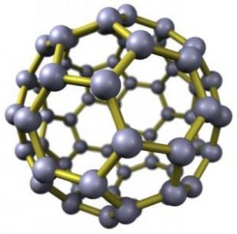
Here introduce the paper, and the paragraphs continue from here and are only separated by headings, subheadings, images and formulae. The section headings are arranged by numbers, bold and 12 pt. Here follows further instructions for authors.
Fig. 1 : Figure insertion.
- Title

All figures should be numbered with Arabic numerals (1,2,...n). All photographs, schemas, graphs and diagrams are to be referred to as figures.
The equations and formulae should be center aligned, while the numberings should be right hand aligned. Present simple formulae in the line of normal text where possible and use the solidus (/) instead of a horizontal line for small fractional terms, e.g., . In principle, variables are to be presented in italics. Refer to equations in the text as "Eq. (1)," etc., or "Equation (1)," etc.
Reference in the text should this way [1], or for several references [1-3]

- Conclusion
Lorem ipsum dolor sit amet, consectetuer adipiscing elit. Maecenas porttitor congue massa. Fusce viverra imperdiet enim. Fusce est. Vivamus a tellus. Pellentesque habitant morbi tristique senectus et netus et malesuada fames ac turpis egestas. Proin pharetra nonummy.
References
[1] Deal, B., Grove, A., General Relationship for the Thermal Oxidation of Silicon, Journal of Applied Physics, 36 (1965.), p. 3770.
[2] Authors, journal, volume (year) pp xx-xx.

